Scene set up:

1. a point light simulating light bulb in the top;

2. a box containing the model as a house;

3. two area lights to lit the model;

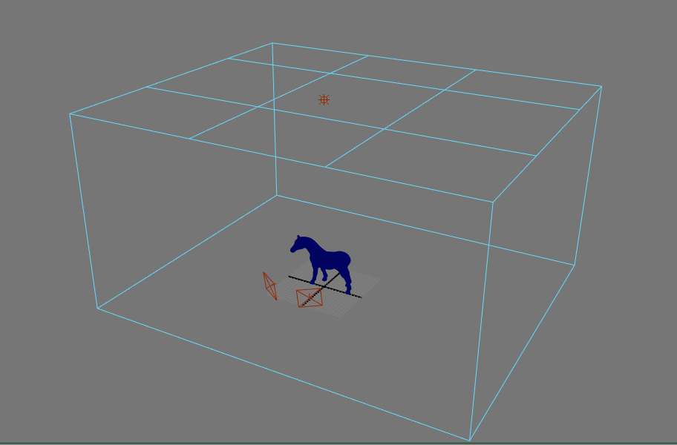

Note:

1. the box should be white material;

2. the material for the model can be Mi_Material_x(matte) or mi_metallic_paint_x

3. Global illumination and Final Gathering are on.